Debunking the Result.html file

**Introduction**

The results.html file is located off the root directory of the project and is rewritten every time a café script is execution. This file contains a lot of information about the execution of a café script, including colors, and text about the execution of the café script. Several colors are used to indicate status. All green indicates everything has passed, red will highlight an error, and yellow text is some type of syntax problems. Along with color highlighting, the results also provides information such as how many scenarios were run, totals steps, pass and fail count, and total execution time. The results file may also report a false positive if the café scripts contains a Scenario Outline-Example. Also when using Scenario Outline, the results file will highlight what examples were used and which ones were skipped.

1. Result.html file location

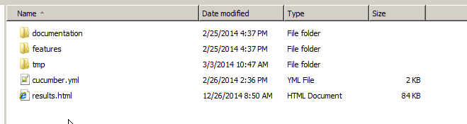

1. Security Issues with Internet Explorer – Internet explorer want to restrict the results pages, click to allow blocked content

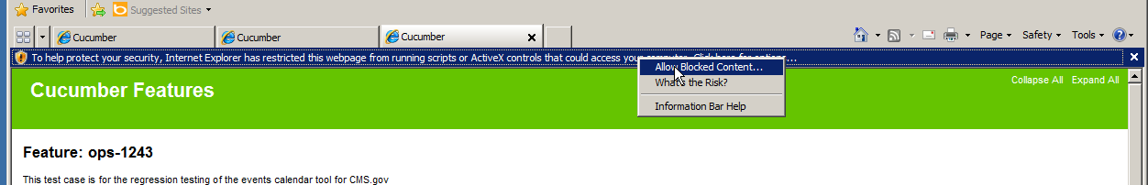

1. Green Passed Script using Scenario Outline

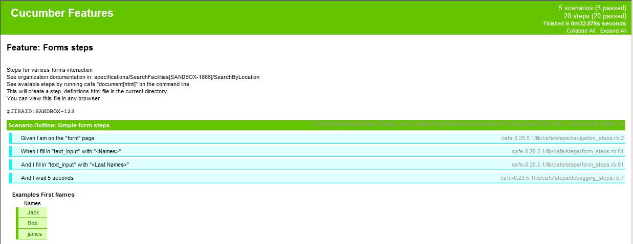

Scenarios executed

Total Steps

Passed, Failed, Skipped

Execution time

Examples used in script

1. Yellow Script using Scenario Outline

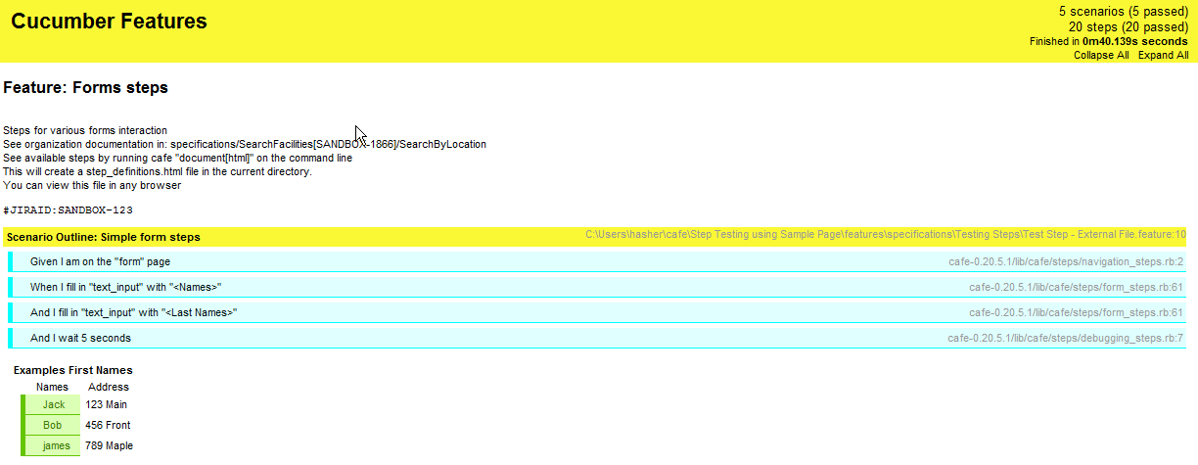

Steps are passed, but scripts has problems

Examples columns that are not used in the script, not highlighted green

1. Yellow Script using Scenario Outline with syntax error.

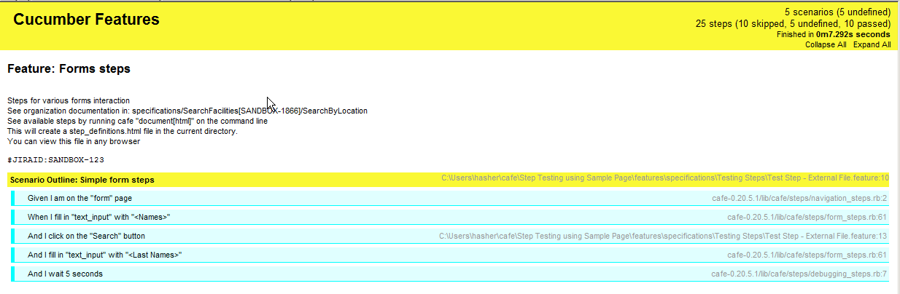

Syntax line is: And I click on the "Search" button

Should be And I click the “Search” Button

Skipped Steps, but café doesn’t identity syntax because of Scenario Outline

1. Red Failed Script

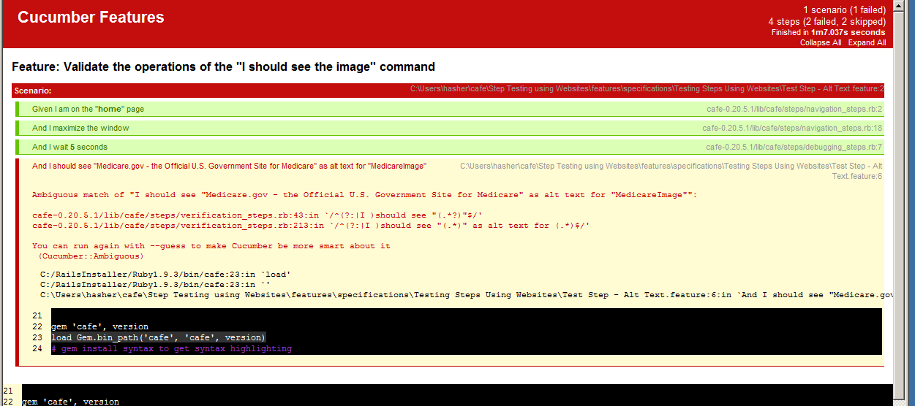

Failed Café Step

Steps Failed, Skipped, Passed